Create a custom docker image for nginx and deploy it using docker compose, where the volume bind mount should be at /var/opt/nginx location. Push the created custom docker image to your docker-hub.

Create a custom docker image for nginx and deploy it using docker compose

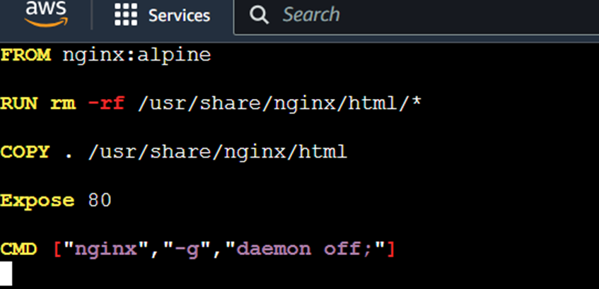

Create docker compose and create a volume in file

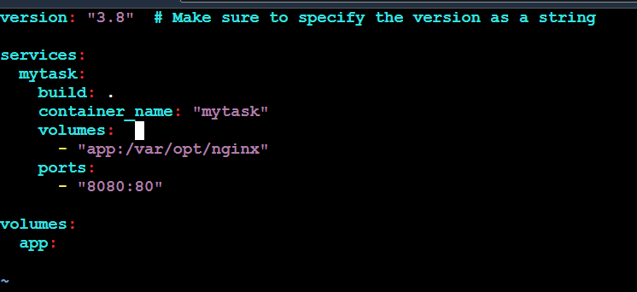

Deploy the file

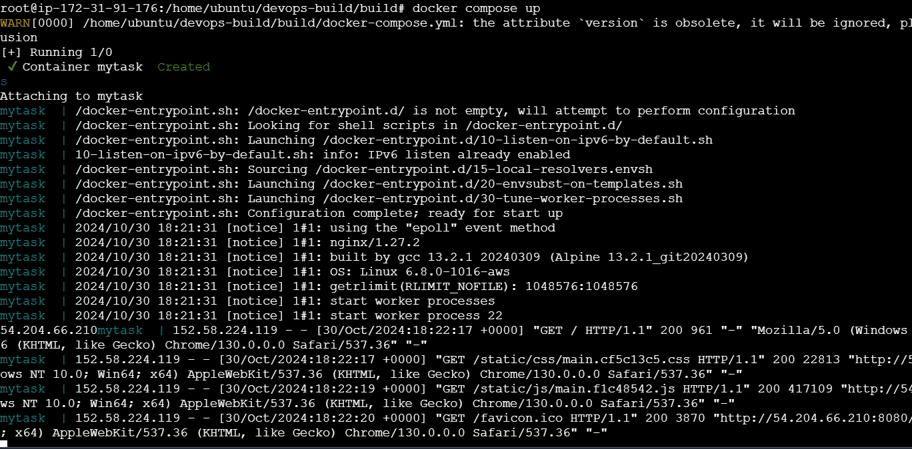

Out put

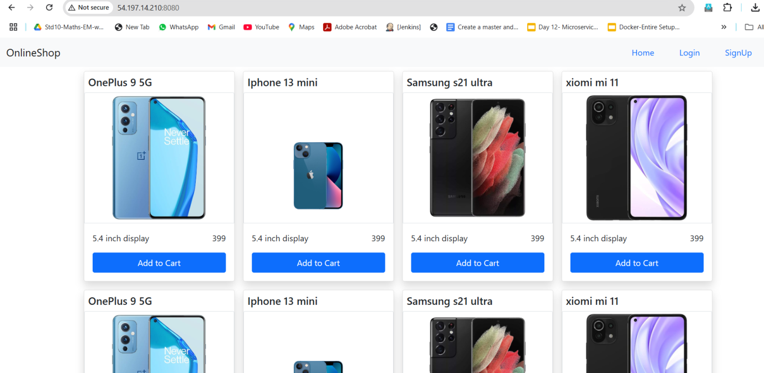

Push into docker repository

